**LAB 8**

**OBJECTIVE**

To be familiar with AJAX

**DESCRIPTION**

AJAX (Asynchronous JavaScript and XML) is a set of web development techniques using many web technologies on the client side to create asynchronous web applications. With Ajax, web applications can send and retrieve data from a server asynchronously (in the background) without interfering with the display and behavior of the existing page. By decoupling the data interchange layer from the presentation layer, Ajax allows web pages and, by extension, web applications, to change content dynamically without the need to reload the entire page. In practice, modern implementations commonly utilize JSON instead of XML.

Ajax is not a single technology, but rather a group of technologies. HTML and CSS can be used in combination to mark up and style information. The webpage can then be modified by JavaScript to dynamically display—and allow the user to interact with—the new information. The built-in XMLHttpRequest object, or since 2017 the new "fetch()" function within JavaScript, is commonly used to execute Ajax on web pages allowing websites to load content onto the screen without refreshing the page. Ajax is not a new technology, or different language, just existing technologies used in new ways.

**HTML**

<!DOCTYPE html>

<html>

<head>

<title>AJAX Example</title>

<script type="text/javascript" src="script.js"></script>

</head>

<body>

<button id="get-data">Get Data</button>

<div class="result"></div>

</body>

</html>

**XML**

<?xml version="1.0" encoding="UTF-8"?>

<bookstore>

<book>

<title>Web Technology</title>

<price>$123</price>

<author>Ram Thapa</author>

<isbn>12345</isbn>

</book>

<book>

<title>Computer Fundamentals</title>

<price>$93</price>

<author>Ajay Shah</author>

<isbn>12353</isbn>

</book>

<book>

<title>Discrete Mathematics</title>

<price>$321</price>

<author>Thomas Butler</author>

<isbn>43216</isbn>

</book>

</bookstore>

**JavaScript**

function getData()

{

var xmlHttp = new XMLHttpRequest();

xmlHttp.open('GET', 'bookstore.xml', true);

xmlHttp.send();

xmlHttp.onreadystatechange = function()

{

if(xmlHttp.readyState == 4)

{

var xmlDoc = xmlHttp.responseXML;

var text = '';

var titles = xmlDoc.getElementsByTagName('title');

for (var i = 0; i < titles.length; i++)

{

text += titles[i].innerHTML+'<br/>';

}

document.getElementsByClassName('result')[0]

.innerHTML = text;

}

}

}

function myFunction()

{

var button = document.getElementById('get-data');

button.addEventListener('click', getData);

}

document.addEventListener('DOMContentLoaded', myFunction);

**OUTPUT**

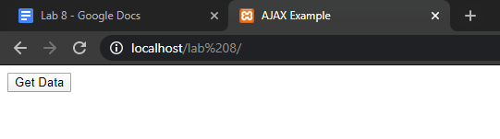

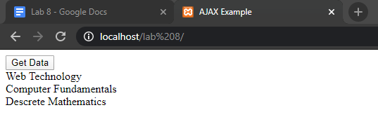

**SUMMARY**

In this lab, we got familiar with AJAX and XML. We wrote a simple program to manipulate the content of the page without refreshing the page using AJAX. We also learned about XML and its syntax.

**COMMENT**